
Swan Orthodontics Oral Hygiene Program (aligners – kids)
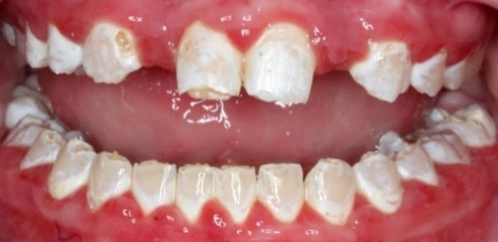
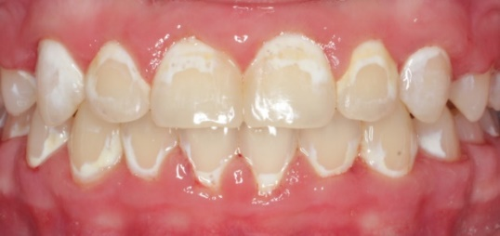
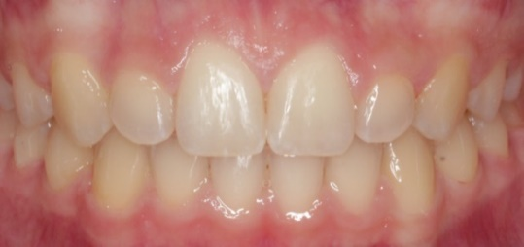
In order to achieve the best possible results, home care is just as important as the work done at appointments. Since you are only seen in our office for a few minutes every 10-20 weeks, a substantial portion of your results are determined by your home care. Poor oral hygiene can ruin an otherwise excellent orthodontic result.
Excellent Hygiene During Treatment Poor Hygiene during Treatment Drinking Pop with Aligners In
Achieving Excellent Oral Hygiene:
Each patient is responsible for making sure their teeth, attachments, and aligners are free from plaque and food debris at all times. There should be no plaque present on any portion of the tooth, especially at the gumline or around the edges of attachments and buttons. Patients will need to brush the teeth and gums properly at least three times each day, especially before replacing the aligners after eating meals or snacks. Instructions for brushing and flossing around any orthodontic appliances are given by our team at the appliance placement appointment, and repeated as needed throughout treatment.
Taking care of your teeth will require much more time than you are used to. Your parents may need to check your teeth and aligners closely to be sure all plaque has been removed. It is important to establish excellent habits early in treatment, since once the gum tissue becomes swollen and irritated plaque can hide down in the little pockets below the puffy edges and these areas are even more difficult to keep clean. We recommend spending some time in the toothbrush aisle at the grocery store, and trying out a few different products to see what works best for you. Toothbrushes, toothpastes, floss, and other oral hygiene aids are not included in your treatment fee.
You should also continue to visit your family dentist at least every six months for a thorough exam and cleaning, and follow through with any treatment needed there (ex: fillings). The x-rays taken by your family dentist are different than the ones we take here, so while we will inform you and your dentist if we happen to see any cavities, they will still need to check for the smaller cavities between your teeth. Many patients benefit from more frequent dental cleanings (every three months) for the duration of orthodontic treatment.
Important Dietary Habits:
Sugary or acidic beverages can also create white spots on the teeth. Examples are juice, sparkling water, pop, lemonade, sports drinks, energy drinks, sweetened coffees, and flavored water. We recommend limiting these drinks to meal times, and brushing before replacing the aligners. Sipping these types of drinks throughout the day with aligners in place is like giving the teeth a constant acid bath, which creates the same white spots that excessive plaque will create. In addition, the tips of the teeth will begin to weaken and chip away. The damage from these drinks can be “sneakier” than the damage from plaque, as it starts as a faint white line around the attachment. We often cannot see this white line until the attachment is removed. Limiting the time these beverages are on the teeth is the best prevention!
Fluoride:
We recommend using toothpaste that contains fluoride, and provide prescriptions for a stronger fluoride toothpaste available for purchase at your local pharmacy. We recommend a bedtime routine of flossing, brushing with this toothpaste, then spitting out the excess but do not rinse before placing the aligners. This lets the fluoride soak in to the tooth surface overnight for maximum protection.

When Oral Hygiene Needs Improvement:
If the patient arrives for an appointment and a problem with oral hygiene is noted, we will not proceed with the scheduled treatment, but instead follow the steps outlined below. This is to protect the patient’s overall dental health, which takes priority over any planned orthodontic procedures. If sufficient oral hygiene cannot be maintained, we will recommend removing the braces.
First Time displaying inadequate oral hygiene:
- We will delay the scheduled procedure to review proper oral hygiene
- We will include parents/guardians in the conversation and ask them for increased help at home.
- We will repeat brushing and flossing instructions, with disclosing agent to color the plaque so you and your parents can see the areas that are being missed with your current brushing technique.
- We will place a fluoride varnish around all attachments and brackets to help protect your teeth.
- We will send letters home and to the family dentist to make sure everyone on our team is on the same page and working together to get the best results.
- We will schedule a virtual follow up in 2 weeks, in which you will submit photos from home to show us your progress.
- We will schedule an in person follow up appointment in 4 weeks to check for progress. These appointments will typically be made during our midmorning hours, which are slower and allow us more time to focus on individualized instruction.
Second Time displaying inadequate oral hygiene:
- We will again delay the previously scheduled procedure to prioritize the necessary improvement in oral hygiene.
- We will include parents/guardians in the conversation and ask them for increased help at home.
- We will repeat brushing and flossing instructions, with disclosing agent to color the plaque so you and your parents can see the areas that are being missed with your current brushing technique.
- We will discontinue aligner wear, so you can practice brushing just around the attachments and brackets, and can floss more easily. This does mean you will lose some of your progress, but it is vital that the teeth be protected from damage.
- We will place another coat of fluoride varnish around all attachments and brackets to help protect your teeth.
- We will send a letter to your dentist, requesting dental cleanings be performed every three months for the duration of your orthodontic care. These visits are typically not covered by insurance, but will be important to maintaining a healthy oral environment to allow us to continue treatment.
- We will send another letter home after this visit to ensure everyone is on the same page.
- We will schedule a visit in 2 weeks for re-evaluation. Enough time will be set aside to remove the attachments and brackets if oral hygiene is still problematic.
Third Time displaying inadequate oral hygiene:
- If the patient arrives again with inadequate oral hygiene, the attachments and brackets will be removed at this appointment.
If at any point during this sequence the oral hygiene improves, we will simply continue with our planned procedures. However, we will only allow two “trips” through these steps. If we have been through the sequence twice, and the patient returns again with poor oral hygiene at any point, we will schedule time to remove the appliances.

___________________________________________________________________________________________
Parent/ Guardian’s Signature Date

